WEEK NUMBER: | 5
STUDENT NAME: | Anas Al Azad
STUDENT ID: | 105694136
Week 5 – Python intro, Google Colab, scikit-learn & Linear Regression

WEEK # | 5
Dates covered: | 31 August -06 September 2026
Lab tasks | What I did | TIME | Learning & Problems
Python introduction  Lab sheet section 1 | - Went through every example in the sheet: variables, operators (+ - * / // % **), string concat/repeat, implicit + explicit type conversion, if/else, if/elif/else, functions, while + for loops, range(), import math.  - Put it all in python_basics_practice.ipynb with a “my try” cell after each topic – e.g. looped over all the “try these variations” numbers at once instead of editing them by hand, caught the error from 123 + "456", used f-strings and enumerate().  - Wrote a small predict_price() function (y = m·x + b) so the Python part links to the linear regression part. | 1.5 h | Learning:  - Python is dynamically typed – int→float happens automatically but int + str doesn't, you have to cast.  - / always gives a float, // floors, % is the remainder; range(10) stops at 9.  - Indentation is the block structure.  Problems:  - The sheet's loop examples use sum as a variable name, which hides the built-in sum() (calling it afterwards gives *'int' object is not callable*). Renamed it to total / used del sum.
Google Colab intro  “Google Colab introduction” PDF | - Read the Colab PDF and built colab_walkthrough.ipynb that follows it: code + text cells, runtime type GPU/TPU, tf.test.gpu_device_name(), TPU check, !pip install, !git clone, file hierarchy, files.upload() and drive.mount().  - Added !nvidia-smi and a second TPU check with tf.config.list_logical_devices('TPU').  - Still to do: run it in Colab on a T4 GPU runtime (screenshots 5.1–5.4). | 1 h | Learning:  - Colab = Jupyter in the browser with the ML libraries preinstalled + free (time-limited) GPU/TPU.  - ! runs a shell command from a cell.  - Session storage gets wiped when the runtime resets – mount Google Drive to keep files.  Problems:  - The sheet's TPU check relies on the COLAB_TPU_ADDR variable, which (as far as I can tell) the newer TPU runtimes don't set, so I added the TensorFlow check as a backup.
scikit-learn + Jupyter set-up  Lab sheet section 3 | - Worked out the local set-up from the sheet: pip install scikit-learn, then jupyter notebook, new notebook, import sklearn.  - Wrote screenshot_demo_setup_check.py – prints the Python/numpy/pandas/sklearn/matplotlib/notebook versions and fits a tiny LinearRegression so I can check everything works in one go.  - Still to do: install it on my laptop + screenshot 5.5. | 0.5 h | Learning:  - sklearn = the “classic ML” library (regression, classification, clustering, dimensionality reduction) with the same fit() / predict() interface for everything.  Problems:  - Easy to mix up: the pip package is scikit-learn but you import sklearn (the old pip install sklearn package name is deprecated).
Linear Regression notebook  Linear_Regression.ipynb | - California Housing: 20,640 houses × 8 features, target = median house value (in $100k).  - LinearRegression().fit() → looked at the 8 learned weights (coef_, e.g. MedInc +0.437, AveBedrms +0.645, Latitude/Longitude about −0.42/−0.43) and the intercept (−36.94).  - Predicted house #5: 2.675 vs true 2.697 – pretty close. MSE = 0.524, and the numpy version np.mean((pred - y)**2) gives exactly the same number.  - Matched it to the theory: y = w0 + w1x1 + … + w8x8, cost J(w) = ½Σ(ŷ − y)². | 1 h | Learning:  - Training = finding the weights that minimise the cost function.  - The sign of a weight shows if a feature pushes the price up or down.  - The notebook measures the MSE on the same data it trained on, which is a bit optimistic (so I tried a proper test split in my extras).  Problems:  - The dataset download (fetch_california_housing) got a 403 Forbidden from the figshare link on the cloud machine I first used – the network there blocks it. Works in Colab, so I'm re-running it there.
Extra – my own experiments  linear_regression_extras.ipynb | - Fitted the 3-house example from the sheet: price = 0.1759 × area + 0.76, so a 2500 sq.ft house ≈ $440.6k (Fig 5.1).  - Coded gradient descent from scratch with the sheet's cost function and update rule – got exactly the same m and b as sklearn (final J = 555.3).  - Learning-rate test: α = 0.005 too slow, 0.05 / 0.3 converge, 0.65 oscillates, 0.7 diverges (Fig 5.2).  - Proper 80/20 train/test split on sklearn's diabetes data: train R² 0.528, test R² 0.453, test MSE ≈ 2900 (Fig 5.3). Same idea for California Housing is part D (needs the download). | 2 h | Learning:  - Feature scaling is basically required for gradient descent.  - GD only converges when α is below a limit (here 2/3); sklearn doesn't need α because it solves least squares directly.  - Test error > training error, so always keep a test set.  Problems:  - GD on the raw areas (~1000s) blew up to a cost of ~1e205 within just 20 iterations. Fixed by standardising the feature (z-score) and converting the weights back afterwards.
TOTAL TIME THIS WEEK |  | 6 h | + about 45 min still to do in Colab

Screenshots:
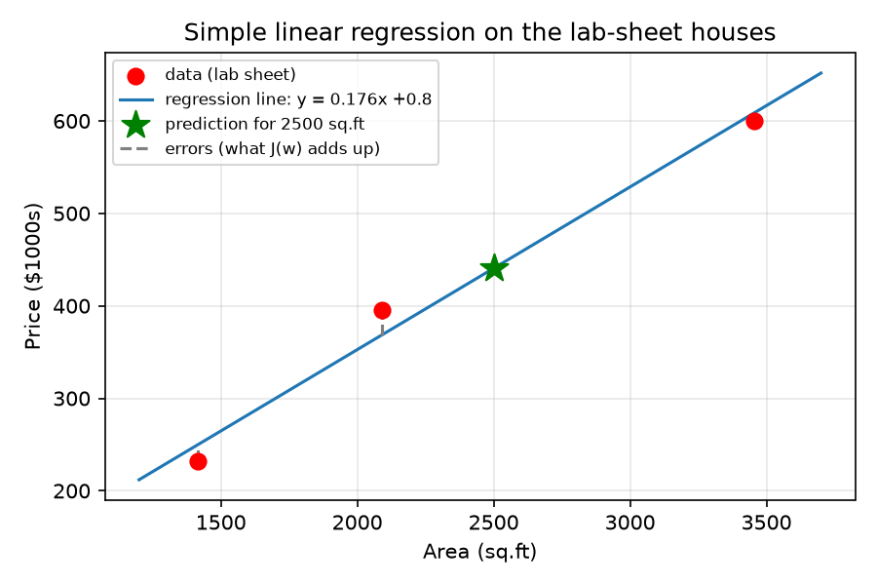
Figure 5.1 – regression line for the 3 houses from the lab sheet (dashed = errors the cost function adds up)
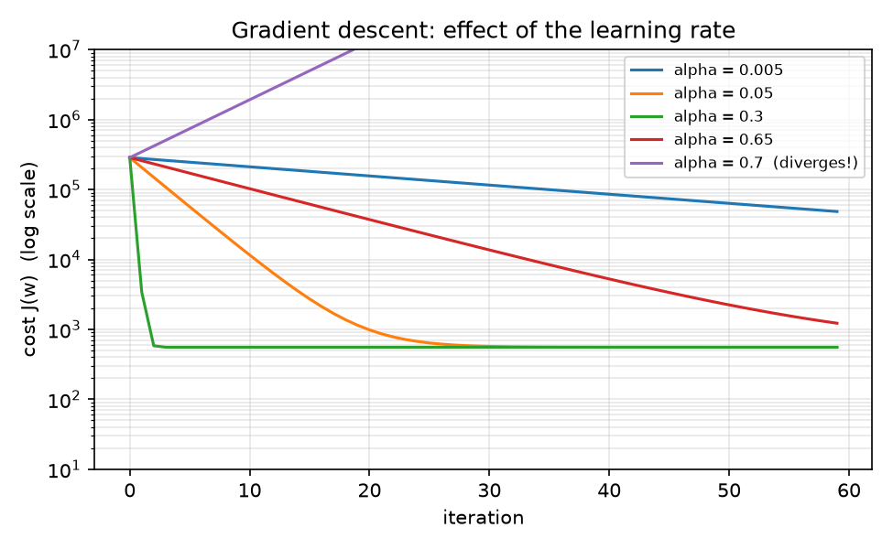
Figure 5.2 – my gradient descent with different learning rates – too small is slow, too big diverges
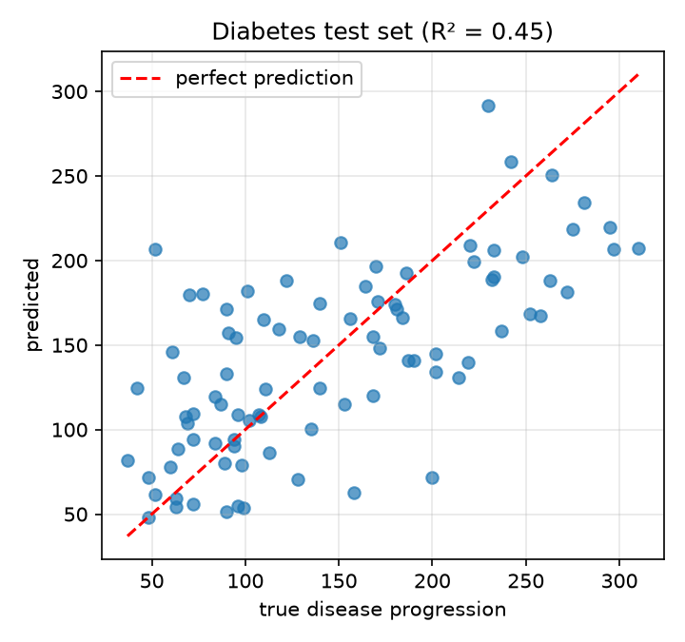
Figure 5.3 – train/test split on the diabetes dataset – predicted vs true on the 20% test set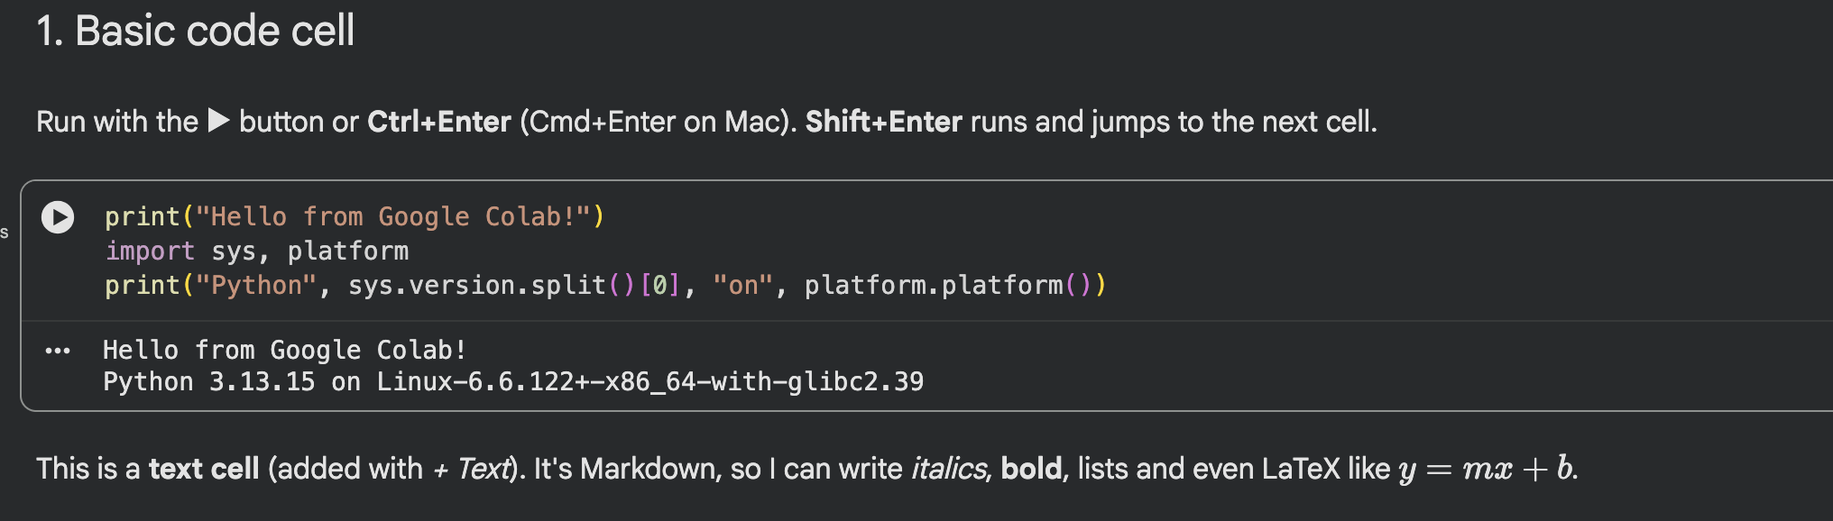
Screenshot 5.1 – Colab – my walkthrough notebook running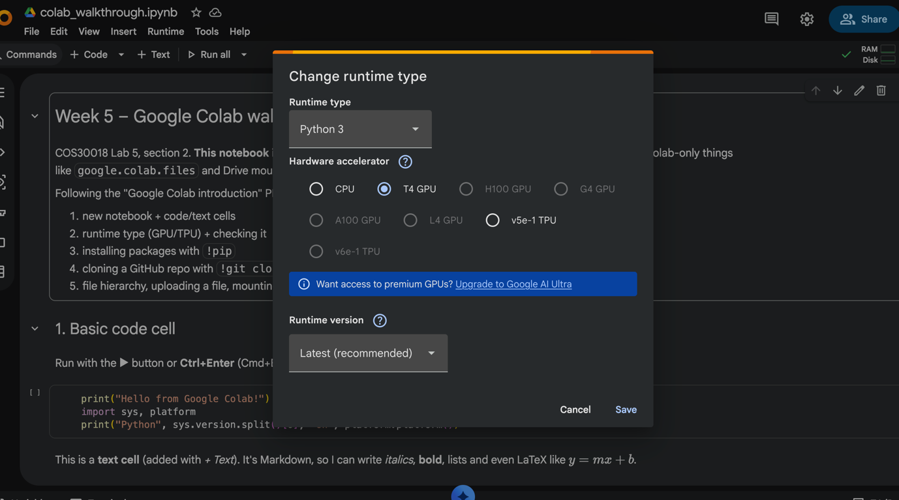
Screenshot 5.2 – Colab – changing the runtime type to GPU
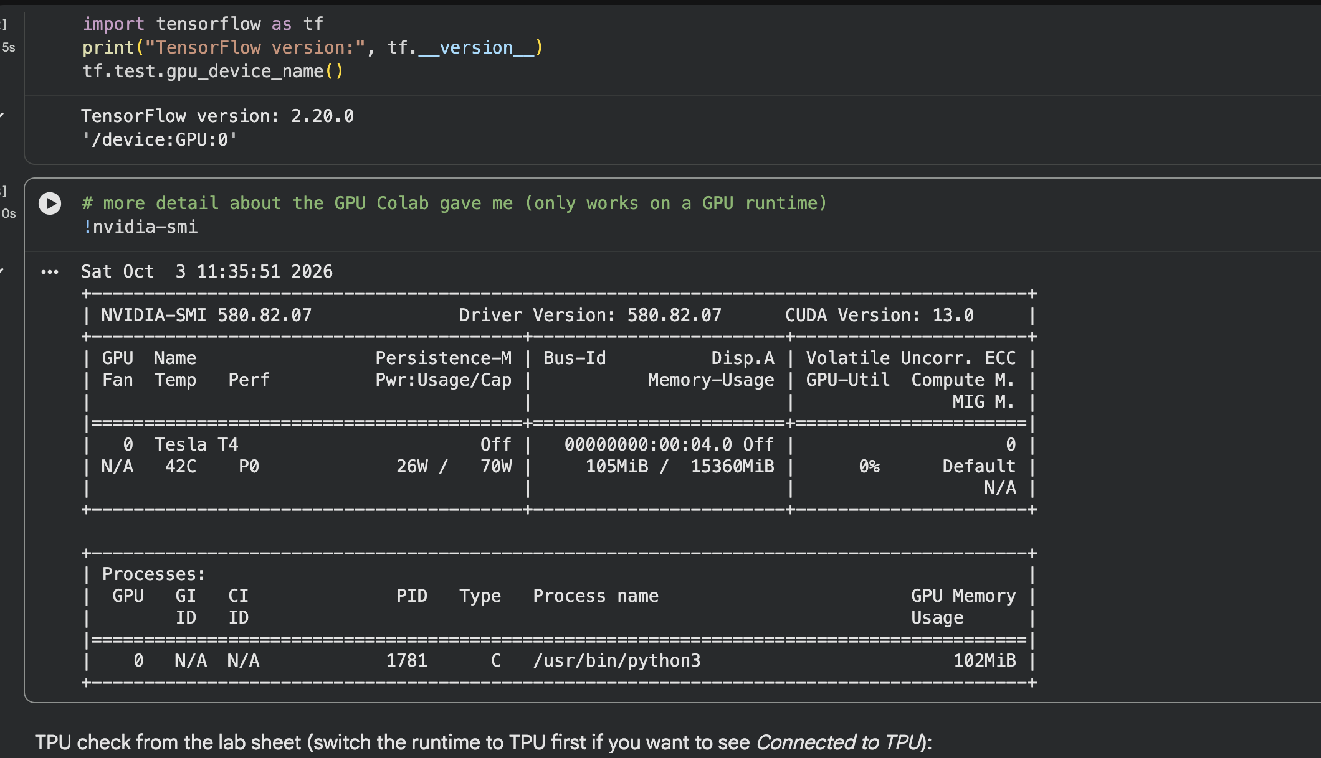
Screenshot 5.3 Colab – GPU check
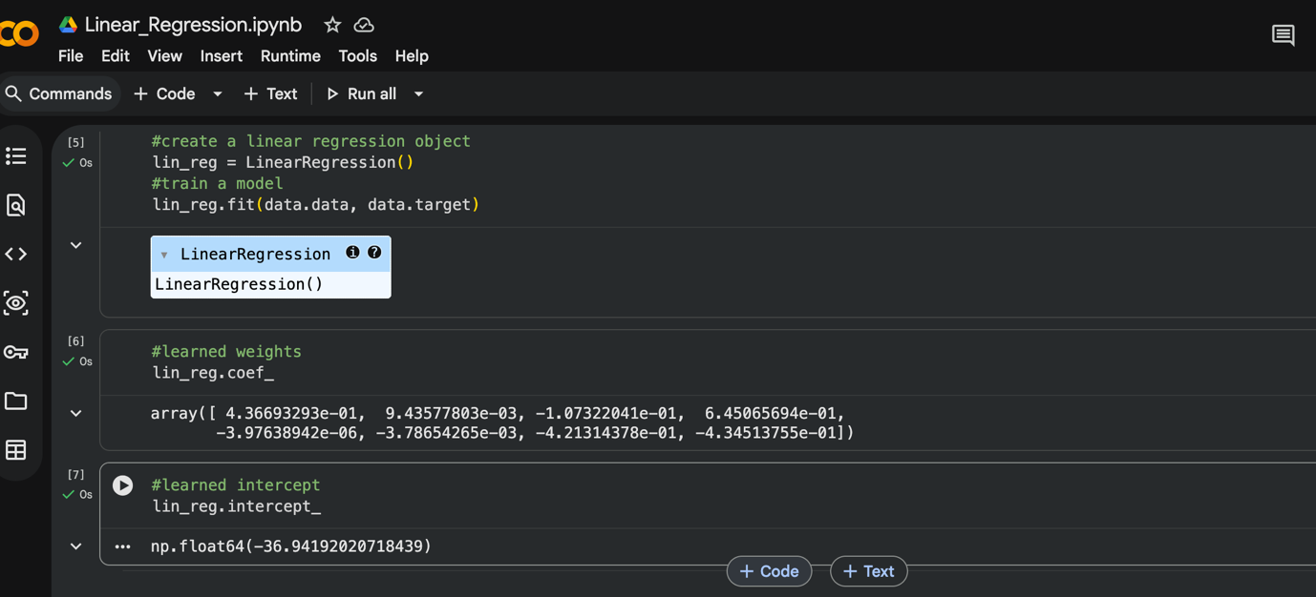
Screenshot 5.4 – Linear_Regression.ipynb in Colab – training
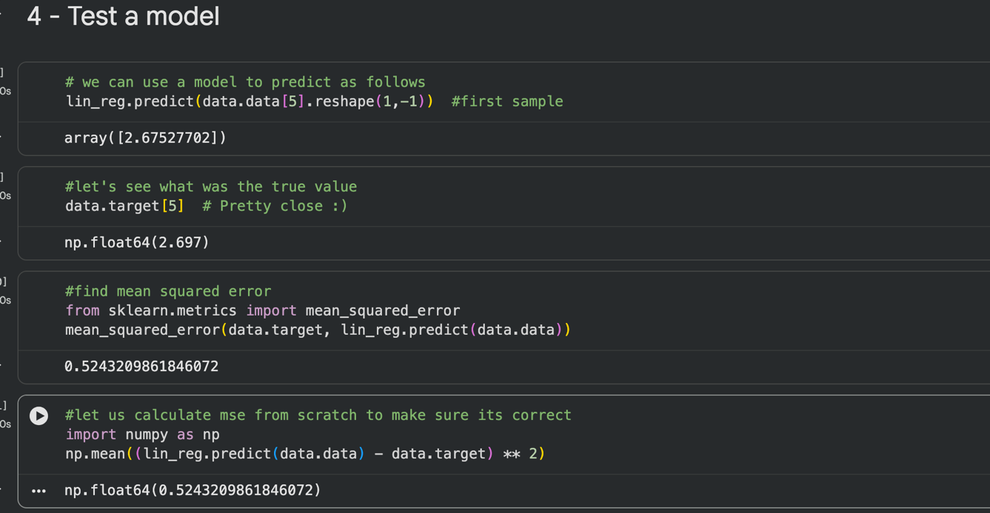
Screenshot 5.5 – Linear_Regression.ipynb in Colab – testing

